Practical activity: Using volumetric and graduated pipettes.
Practical Guide – Volumetric and Graduated Pipettes

Aim: To practice three methods of using volumetric and graduated pipettes to pipette precise amounts of liquid.
Notes and guidance
Speak with your technician colleague in advance of this practical as they may need time to prepare resources. It may be that some equipment is not available, especially if your school does not have an A level chemistry course. In this case, it is advisable to at least show students a video of this equipment in use so they are familiar with it in case it appears in an exam question.

Emphasise the differences between volumetric and graduated pipettes to students. Volumetric pipettes are calibrated to precisely pipette one given volume of liquid, whereas graduated pipettes can measure out varying volumes of liquid.

If available, you may wish also to demonstrate the use of an automatic pipette/micropipette.

If you choose to use any liquid other than water in this experiment, ensure all pipettes and fillers are thoroughly cleaned after the experiment to ensure they are not contaminated for future use.

Risk Assessment Notes
A risk assessment must be completed for this practical. The risk assessment should be specific to the class involved and written only by the teaching member of staff. For more guidance refer to CLEAPSS. It is good practice for students to wear safety spectacles during all class practicals and demos.

Equipment | 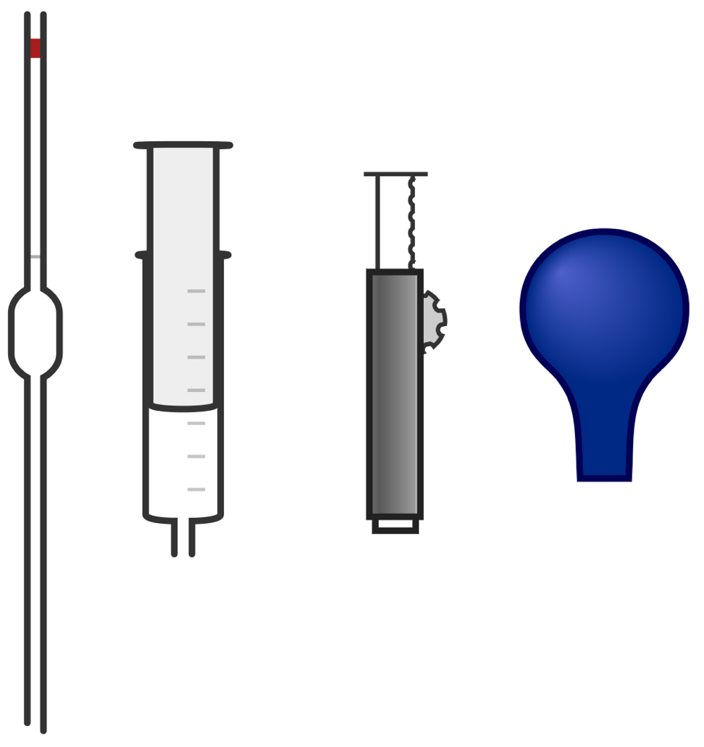
Apparatus:
- Beakers
- Graduated/volumetric pipette
- Rubber bulb pipette filler
- Pi-pump pipette filler
- Syringe
- Rubber tubing

Chemicals:
- Access to water

Method 1: Rubber Bulb Filler |  | Picture 1: Rubber Bulb Filler
- Carefully insert a pipette into the bottom of the rubber bulb filler.  - Expel the air inside the bulb by pinching the valve at 1 and squeezing.  - Dip the bottom of the pipette into the liquid and squeeze the valve at 2.  - As the liquid is drawn into the pipette, ensure the bottom of the pipette remains beneath the water level.  - Keep filling the pipette until the liquid level is just above the graduation mark you require.  - Hold the pipette at eye level above the beaker of liquid and squeeze the valve at 3 gently until the bottom of the meniscus is level with the graduation mark.  - Move the pipette above your intended receptacle and expel the liquid by squeezing the valve at 3 firmly. |  | 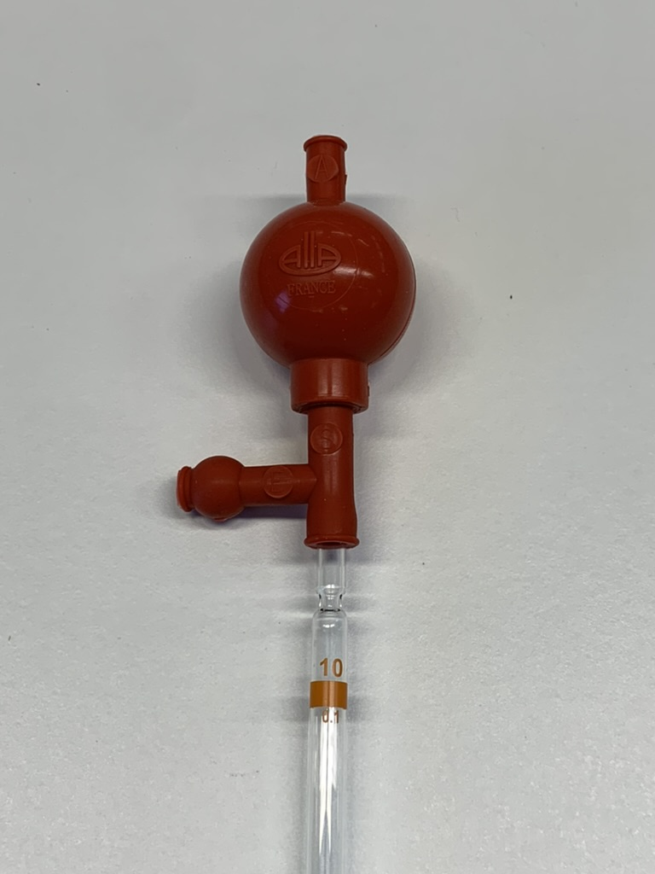
Method 2: Pi-Pump |  | Picture 2: Pi-Pump
- Carefully insert a pipette into the bottom of the Pi-pump pipette filler.  - Push the thumbwheel at 1 up to ensure the plunger at 2 is at its lowest point.  - Dip the bottom of the pipette into the liquid and use the thumbwheel to draw liquid into the pipette.  - As the liquid is drawn into the pipette, ensure the bottom of the pipette remains beneath the water level.  - Keep filling the pipette until the liquid level is just above the graduation mark you require.  - Hold the pipette at eye level above the beaker of liquid and turn the thumbwheel until the bottom of the meniscus is level with the graduation mark.  - Move the pipette above your intended receptacle and expel the liquid by squeezing the release lever valve at 3. |  | 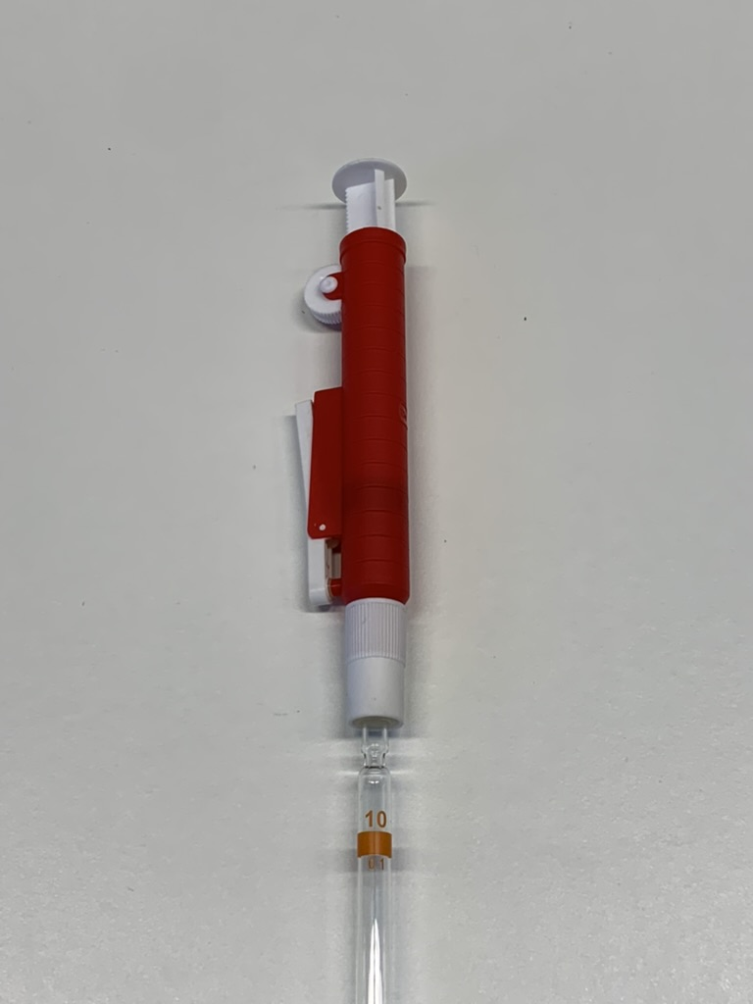
Method 3: Syringe |  | Picture 3: Syringe
- Connect a syringe to the pipette via a short length of rubber tubing. Ensure the syringe used is of a greater volume than the pipette.  - If it is not already, full depress the syringe plunger.  - Dip the bottom of the pipette into the liquid and gently pull the plunger up.  - As the liquid is drawn into the pipette, ensure the bottom of the pipette remains beneath the water level.  - Keep filling the pipette until the liquid level is above the graduation mark you require.  - Remove the rubber tubing quickly and place a finger over the top of the pipette, ensuring you create an airtight seal.  - Hold the pipette at eye level above the beaker of liquid and slightly lift your finger to allow liquid to escape slowly until the bottom of the meniscus is level with the graduation mark.  - Move the pipette above your intended receptacle and expel the liquid by removing your finger from the top of the pipette. |  | 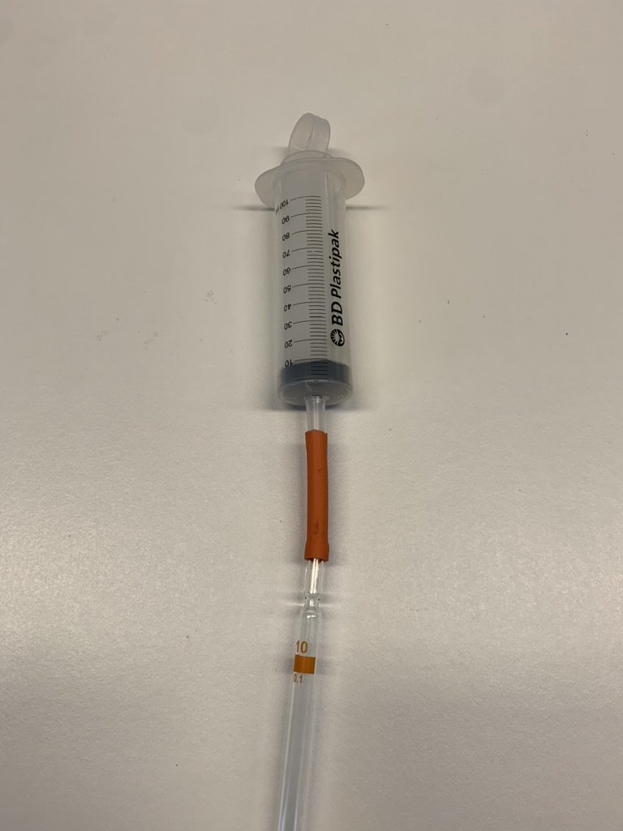
Questions To Ask Students During The Practical
- Why must we ensure the bottom of the pipette remains below the surface of the liquid while filling the pipette? (If we do not then the pipette will draw in air. There will then be bubbles inside the pipette and less liquid than the graduation marks tell us.)
- Why do we read the liquid level at eye level? (At eye level we can clearly see the true bottom of the miniscus and our readings are not confused by perspective.)
- Which pipette filler did you find the easiest to use accurately?

Clearing up
It is important that equipment is returned to the prep room in good order. If safe to do so, rinse used equipment and put it in the used equipment tray. If the trays arrived on a trolley, students must return all trays and equipment to that trolley. Anything dirty needs to be placed into a separate container for washing up. Never put dirty equipment back into a tray with clean equipment.

If you choose to use any liquid other than water in this experiment, ensure all pipettes and fillers are thoroughly cleaned after the experiment to ensure they are not contaminated for future use.

Technician Notes
Ensure the solutions you provide are free from contamination and the equipment is as clean as possible.

Discuss this practical with the class teacher ahead of time. Ensure they have considered the risks of this practical and are confident with the techniques used. If necessary, provide them with the appropriate CLEAPSS so they are comfortable with the chemicals to be used and how to use and dispose of them safely.

If you choose to use any liquid other than water in this experiment, ensure all pipettes and fillers are thoroughly cleaned after the experiment to ensure they are not contaminated for future use.

